 | 

CNRS-L/AUB PhD Fellowships Program

2019-2020
For PhD students enrolled in AUB

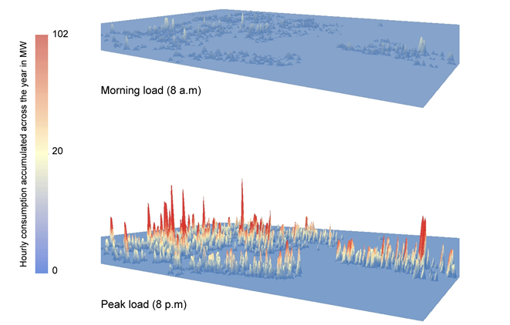

Beirut Energy Model BEEM- Simulated electricity consumption of the buildings in the Bachoura area (Centre for Remote Sensing and CESBIO France)

Application File
Deadline for receipt of applications is May 6, 2019.

Name of Applicant:

Name of Thesis Advisor:

AUB Dept & Faculty:

Semester joined PhD program at AUB:

Expected semester of graduation:

- Information Sheet about the Applicant

I.1-Civil Status (Please attach copy of Lebanese ID-civil register)
PHOTO

Last Name: ……………………………………………………………

First Name: …………………………………………………………...

Full name (in Arabic):

Date & Place of Birth: ……………………………………………

Date & Place of Birth (in Arabic):

Age: ……………… Nationality: ………………….……………

ID/Passport Number: ……………………………………………….

Address: …………………………………………….....................

P.O. Box: ………………… City: …………………….……………..

Telephone: ……………………………

E-mail:

I.2-Degrees* (Received and/or expected)

Degree | Major/Speciality | Transcripts | Date & Institution
Baccalaureate
BS
Master’s
Engineering
PhD
* Attach your CV, copies of Baccalaureate and university degrees, and transcript of grades (unofficial copy is acceptable).

II-Information Sheet about the Host department
Department:

Faculty:

Address:

P.O. Box & City:

Tel. & Email:

Name of Dept Chairperson:

Tel.:

Name of Thesis Advisor:

Tel.:

PhD Thesis Committee Members and affiliations:

1-

2-

3-

4-

5-

Is the thesis advisor affiliated with the host department: □ Yes/ □ No

If no, please specify his/her affiliation and coordinates:

Main research themes of the working group the applicant will join:

List of recent publications by the working group (relevant to the thesis topic):

- PhD Thesis

III.1-Title:

- The thesis is part of a research project funded by the CNRS-L: □ Yes/ □ No

If yes, specify:

- The thesis topic fits one of the CNRS-L priorities for 2019-2020
- (Annex): □ Yes/ □ No
If yes, select from the Annex (possible to select more than one):
If not, define one:

- The thesis is co-supervised by another institution: □ Yes/ □ No
If yes, specify:

III.2- Abstract (not more than 300 words)

III.3- Background and rationale of the thesis (not more than 200 words)

III.4- Scopes and outputs (not more than 200 words)

III.5- Applied and/or innovative aspects (not more than 200 words)

III.6- State of art of the working group (not more than 200 words)

III.7- Thesis research plan (not more than 200 words)

III.8- Thesis advisor comments (Kindly provide your assessment of the thesis topic, subject and, among other, the suitability of the applicant to complete the proposed studies) (not more than 100 words)

Signature (of thesis advisor):

IV- Statement

As an AUB Doctoral student and applicant to the CNRS-L/AUB PhD Award program, this is to confirm that I am currently:

- Receiving full tuition and stipend from AUB
- Receiving full tuition from AUB
- Not receiving any fellowship from AUB
- Others: _________________________________________________________

Date:

Signature (of applicant): ___________________________

Contents of the Application File: (Check List)

