 | 

CNRS-L/LAU PhD Award Program

2016-2017

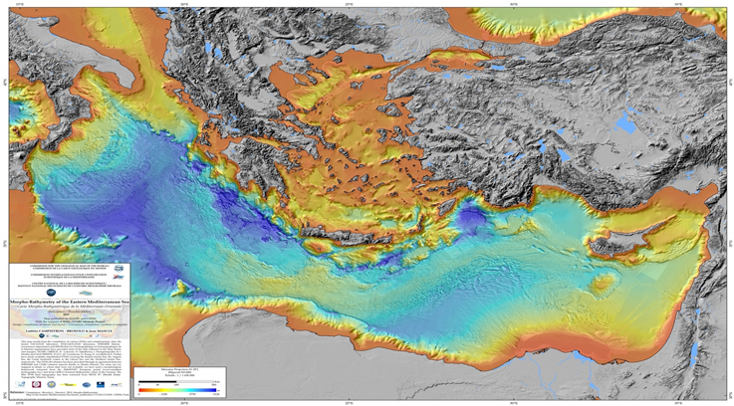

Morpho-Bathymetry of the Eastern Mediterranean Sea: the Levantine basin data is provided by the SHALIMAR bathymetric campaign of 2003, that has been conducted with the naval resources of the French Ifremer and with a team of researchers from CNRS-L and the Institut de Physique du Globe de Paris

Eligibility
These awards are exclusively for Lebanese students holding a Master's degree (or equivalent) recognized as such by the two institutions (CNRS-L and LAU). Considered eligible, Lebanese applicants under the age of 30, and having 14/20 (French system) or 85/100 (American system) as overall average in the Master’s degree (or equivalent).

Scientific priorities for 2016-2017

All topics of common interest are eligible. Nevertheless, topics considered as priorities for 2016-2017 are listed in the annex. It should be noted, however, that "exceptional" applications belonging to another topic (not listed in the annex) are also considered.

The final selection of awardees will be done by a joint committee from both institutions (CNRS-L and LAU).

Contents of the Application File:
(Check List)

- Application file (with original signatures)
- Identity card (civil register)
- Curriculum Vitae; Copy of Baccalaureate & University Degrees; Transcript of Grades
- Applicant’s Letter of Intent (attach to application)
- Acceptance in the doctoral program at LAU (and abroad if any)
- Two letters of recommendation (attach to application)
- Publications by applicant (if any; attach copies to application)
- Signed copy of the CNRS-L code of ethics and deontology (by the supervisor)

The application and documents listed above must be submitted to:

Mrs Gracia Zgheib-Mahfoud
Program Officer
Graduate Studies & Research; ext. #: 2547
Byblos Campus, Block A, Room 705
Lebanese American University

Deadline for receipt of applications is June 23, 2016.

Application File

Name of Applicant:

Name of Thesis Advisor:

LAU School & Dept.:

Foreign advisor (if any) and affiliation:

- Information Sheet about the Applicant

I.1-Civil Status (Please attach copy of Lebanese ID-civil register)
PHOTO

Last Name: ……………………………………………………………

First Name: …………………………………………………………...

Date & Place of Birth: ……………………………………………

Age: ……………… Nationality: ………………….……………

ID/Passport Number: ……………………………………………….

Address: …………………………………………….....................

P.O. Box: ………………… City: …………………….……………..

Telephone: ……………………………

I.2-Degrees* (Received and/or expected)

Degree | Major/Speciality | Transcripts | Date & Institution
Baccalaureate
BS
Master’s
Engineering
PhD

* Attach your CV, copies of Baccalaureate and university degrees, and transcript of grades (unofficial copy is acceptable).

II-Information Sheet about the Host department at LAU

Department:

School:

Address:

P.O. Box & City:

Name of Dept. Chairperson:

Tel. & E-mail:

Name of Thesis Advisor:

Tel. & E-mail:

PhD Thesis Committee Members (if any) and affiliations:

1-

2-

3-

4-

5-

Is the thesis advisor affiliated with the host department: □ Yes/ □ No

If no, please specify his/her affiliation and coordinates:

Main research themes of the working group the applicant will join:

List of recent publications by the working group (relevant to the thesis topic):

III-Information Sheet about the Host department abroad (if any)

Laboratory:

Faculty:

Doctoral School:

University:

Address:

P.O. Box & City:

Name of lab. Chairperson:

Tel. & E-mail:

Name of Thesis Advisor:

Tel. & E-mail:

Is the thesis advisor affiliated with the host laboratory: □ Yes/ □ No

If no, please specify his/her affiliation and coordinates:

Main research themes of the working group the applicant will join:

List of recent publications by the working group (relevant to the thesis topic):

- PhD Thesis

IV.1-Title:

- The thesis is part of a research project funded by the CNRS-L: □ Yes/ □ No

If yes, specify:

- The thesis topic fits one of the CNRS-L priorities for 2016-2017 (Annex) : □ Yes/ □ No
If yes, select from the Annex (possible to select more than one):
If not, define one:

- The thesis is co-supervised by another institution (local or abrad) : □ Yes/ □ No
If yes, specify:

IV.2- Abstract (not more than 300 words)

IV.3- Background and rationale of the thesis (not more than 200 words)

IV.4- Scopes and outputs (not more than 200 words)

IV.5- Applied and/or innovative aspects (not more than 200 words)

IV.6- State of art of the working group (not more than 200 words)

IV.7- Thesis research plan (not more than 200 words)

IV.8- Thesis advisor comments (Kindly provide your assessment of the thesis topic, subject and, among other, the suitability of the applicant to complete the proposed studies) (not more than 100 words)

Signature (supervisor)

V- Statement

As an LAU Doctoral student and applicant to the CNRS-L/LAU PhD Award program, this is to confirm that I am currently:

- Receiving full tuition and stipend from LAU
- Receiving full tuition from LAU
- Not receiving any fellowship from LAU
- Others: _________________________________________________________

Date:

Signature (of applicant): ___________________________

Annex: CNRS-L priorities for PhD/ 2016-2017
Cultural heritage  - Archaeology  - Protection, conservation and restoration of artifacts and ancient manuscripts  - Archaeometry | الإرث الثقافي  - علم الآثار  - حماية, حفظ و ترميم اللقى الأثرية و المخطوطات القديمة  - إستخدام تقنيات كيميائية و فيزيائية و هندسية في علم الآثار
Arabic language and History  - Arabic linguistics, dynamism, and history  - Cognitive linguistics (in Arabic)  - History of Science in Arabic civilization  - Arabization of softwares | اللغة العربية و التاريخ  - اللسانيات العربية, ديناميتها, و تاريخها  - اللغويات المعرفية (في العربية)  - تاريخ العلوم في الحضارة العربية  - تعريب البرمجيات
Sociology and political science  - Migration sociology  - Conflict resolution and Post-conflict societies  - Gender and feminist studies  - Ethics in media coverage of conflicts (conventional and social medias) | العلوم الإجتماعية و السياسية  - سوسيولوجيا الهجرة و النزوح  - فض النزاعات و مجتمعات ما بعد النزاع  - الدراسات الجندرية و النسوية  - أخلاقيات التغطية الإعلامية للنزاعات (الوسائل الإعلامية التقليدية و وسائل التواصل الإجتماعي)
Economics and Finance  - Entrepreneurial university and innovation  - Economy of conflict areas  - Lebanon as potential destination for offshoring  - Actuarial science and Financial risk management  - Mathematical and computer modeling applied to finance and economy | إقتصاد و مالية  - الجامعة الريادية و الإبداع  - إقتصاد مناطق النزاع  - لبنان كوجهة محتملة في إعادة التموضع الإقتصادي العالمي  - العلم الأكتواري و إدارة المخاطر المالية  - تطبيقات البرمجة الرياضية و المعلوماتية في العلوم المالية و الإقتصادية
Environment and natural resources
- Valorization of Lebanese coastal zones
- Petroleum studies
- Sustainable water management
- Renewable energy
- Biodiversity & speciation
- Geophysics, geology, geodesy
- Mitigation & management of natural risks
- Air quality
- Urban planning in the age of climate change
Agriculture and food
- Challenges of agricultural activities
- Food safety and food industry
- Veterinary medicine
- Pest and Alien species
Medical sciences
- Addictive Diseases
- Cancer Research
- Cardiovascular diseases
- Clinical pharmacology. Pharmacy
- Clinical Immunology and Immunopathology
- Diseases of Bones and Joints
- Endocrinology
- Geriatrics
- Infectious Diseases
- Medical Microbiology
- Mental Disorders, Psychosomatic Diseases
- Metabolic Disorders
- Methods of Epidemiology and Preventive Medicine
- Psychiatry
- Neurophysiology and Brain Research.
- Public Health and Health Services
- Respiratory Diseases
- Ethics in medicine and medical research
Basic science
- Theoretical and particle physics
- Astrophysics
- Peaceful use of nuclear techniques
- Forensic chemistry
- Green chemistry
- New functional materials
- Biomedical engineering
- Biochemistry
- Molecular and cellular Biology
- Genetics
- Radiobiology

