CNRS-L Doctoral Fellowships

2017-2018

Partial scholarships (half scholarships) for students having a complementary scholarship from foreign universities
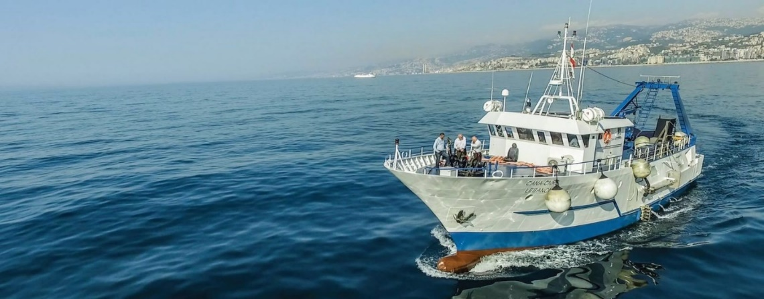
CANA-CNRSL Research Vessel for Marine Research in Lebanon

Content of the Application File:
- Application file (with original signatures)
- Civil register (إخراج قيد)
- Official ID photo (صورة شمسية)
- Curriculum Vitae; Copy of Baccalaureate & University Degrees; Transcript of Grades
- Applicant’s Letter of Intent (attach to application)
- Two letters of recommendation (attach to application)
- Publications by applicant (if any; attach copies to application)
- Official admission in PhD studies from a foreign university
- Attestation of partial scholarship from the PhD university or other academic/research institution

The application and documents listed above must be submitted before October 25, 2017 to:

National Council for Scientific Research
Register office, 2nd floor
59, Zahia Salmane Street- Jnah
Beirut, Lebanon

Electronic copy of the complete application (and documents) should also be sent to:
tamara.elzein@cnrs.edu.lb

Application File

(To be filled in English or French)
Name of Applicant:

Name of Thesis Advisor (s):

Laboratory (or Department) & Faculty:

University:

- Information Sheet about the Applicant

I.1-Civil Status (Please attach copy of Lebanese civil register)

Last Name:

First Name:

Full name (in Arabic):

Date & Place of Birth:

Date & Place of Birth (in Arabic):

ID/Passport Number:

Address:

City:

Telephone:

E-mail:

I.2-Degrees* (Received and/or expected)

Degree | Major/Speciality | Transcripts | Date & Institution
Baccalaureate
BS
Master’s
Engineering
PhD |  | *(if applicable)
* Attach your CV, copies of Baccalaureate and university degrees, and transcript of grades.

Scanned Photo

II-Information Sheet about the Host University

Laboratory (or Department):

Faculty:

Address:

P.O. Box & City:

Name of laboratory Chairperson:

Tel.:

Name of Thesis Advisor:

Tel. & Email:

Main research themes of the working group the applicant will join:

List of recent publications by the working group (relevant to the thesis topic):

- PhD Thesis

III.1-Title:

- The thesis is co-supervised by another institution : □ Yes/ □ No
If yes, specify:

III.2- Abstract (not more than 100 words)

III.3- Background and rationale of the thesis (not more than 200 words)

III.4- Scopes and outputs (not more than 200 words)

III.5- Methodology (not more than 100 words)

III.6-Originality of the proposal (kindly highlight if the proposal might be considered original within its field: “Emerging disciplines”, “Humanities and related fields”, or “Topics leading to a transfer of emerging technologies to Lebanon”) (not more than 100 words)

III.7- Expected impact for Lebanon (scientific and/or socio-economic) (not more than 200 words)

III.8- Thesis advisor comments (Kindly provide your assessment of the thesis topic, subject and, among other, the suitability of the applicant to complete the proposed studies) (not more than 100 words)

Date

Signature (supervisor)

Signature (applicant)

